

University of Delhi, Delhi, India
IS Practical File

For

Semester VIII

Name – Chandan Kumar
University Exam Roll No: 22035570035
Program: B.sc (Hons.) Computer Science
Department: Computer Science

Practical -01: Demonstrate the use of Network tools: ping, ipconfig, ifconfig, tracert, arp, netstat, whois.

- Ping
The “ping” command allows you to send a signal to another device, and if that device is active, it will send a response back to the sender. The “ping” command is a subset of the ICMP (Internet Control Message Protocol).

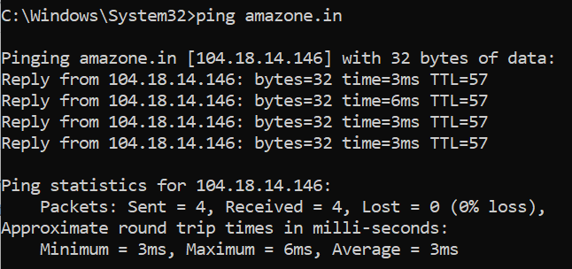

- Ipconfig/ipconfig all
ipconfig is a Windows command-line tool used to display, troubleshoot, and manage network configuration. Basic ipconfig command shows IP address, subnet mask, and default gateway for active adapters.
While, ipconfig/all reveals full network details: MAC address, DHCP server, DNS server, and lease time.
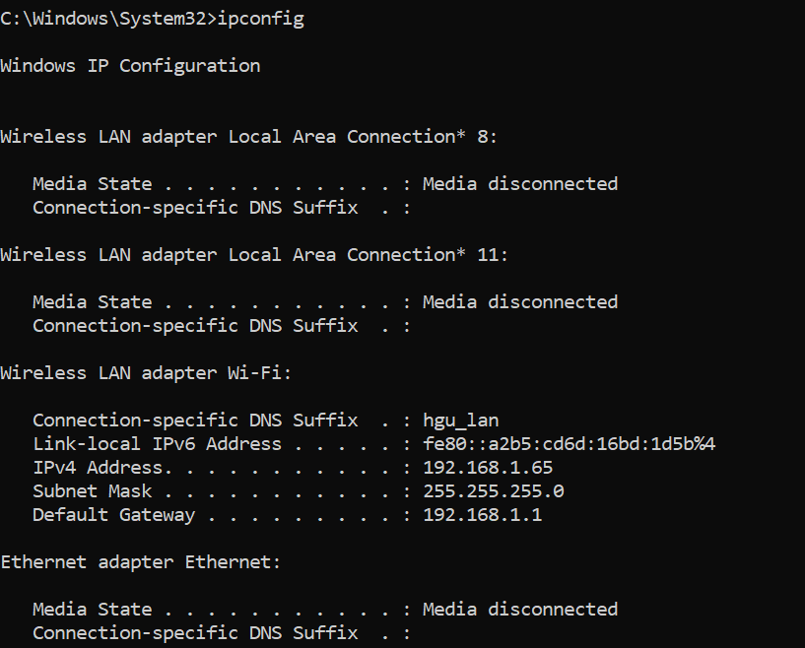
- Ifconfig:
The ifconfig (interface configuration) command is a classic Linux networking utility used to view and configure network interfaces.

- Tracert
This command lets you see all steps a packet takes to the destination. For example, if we send a packet to www.google.com, it actually goes through a couple of routers to reach the destination. The packet will first go to your router, and then it will go to all kinds of different routers before it reaches Google servers.
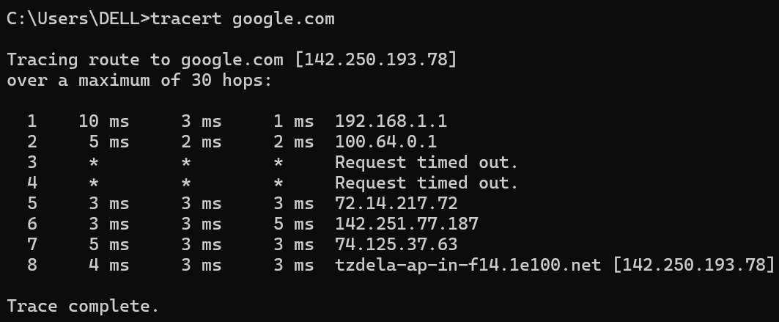

- whois
The whois command looks up the registration record associated with a domain name. This can show you more information about who registered and owns a domain name, including their contact information.
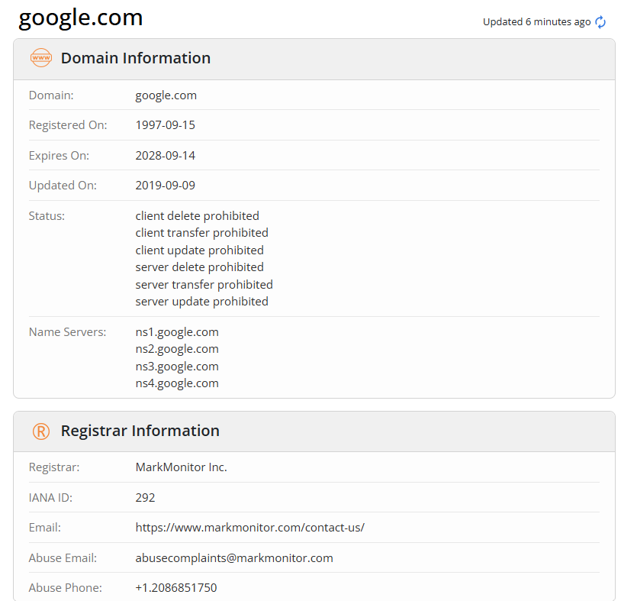

- arp:
The arp (Address Resolution Protocol) command is a networking tool used to view and manage the IP-to-MAC address mapping cache on a computer, facilitating communication between devices on a local network. It is commonly used for troubleshooting connectivity, identifying connected devices, and detecting ARP spoofing attacks

- netstat:
The netstat (network statistics) command is a command-line tool used to display active TCP connections, listening ports, routing tables, and network interface statistics. It helps diagnose networking issues and monitor traffic on Windows, Linux, and Unix-like systems. Common uses include finding PID, listening ports, and monitoring protocol statistics.

Practical-02: Use of Password cracking tools: John the Ripper, Verify the strength of passwords using these tools.

Practical -04: Use Burp proxy to capture and modify the message.
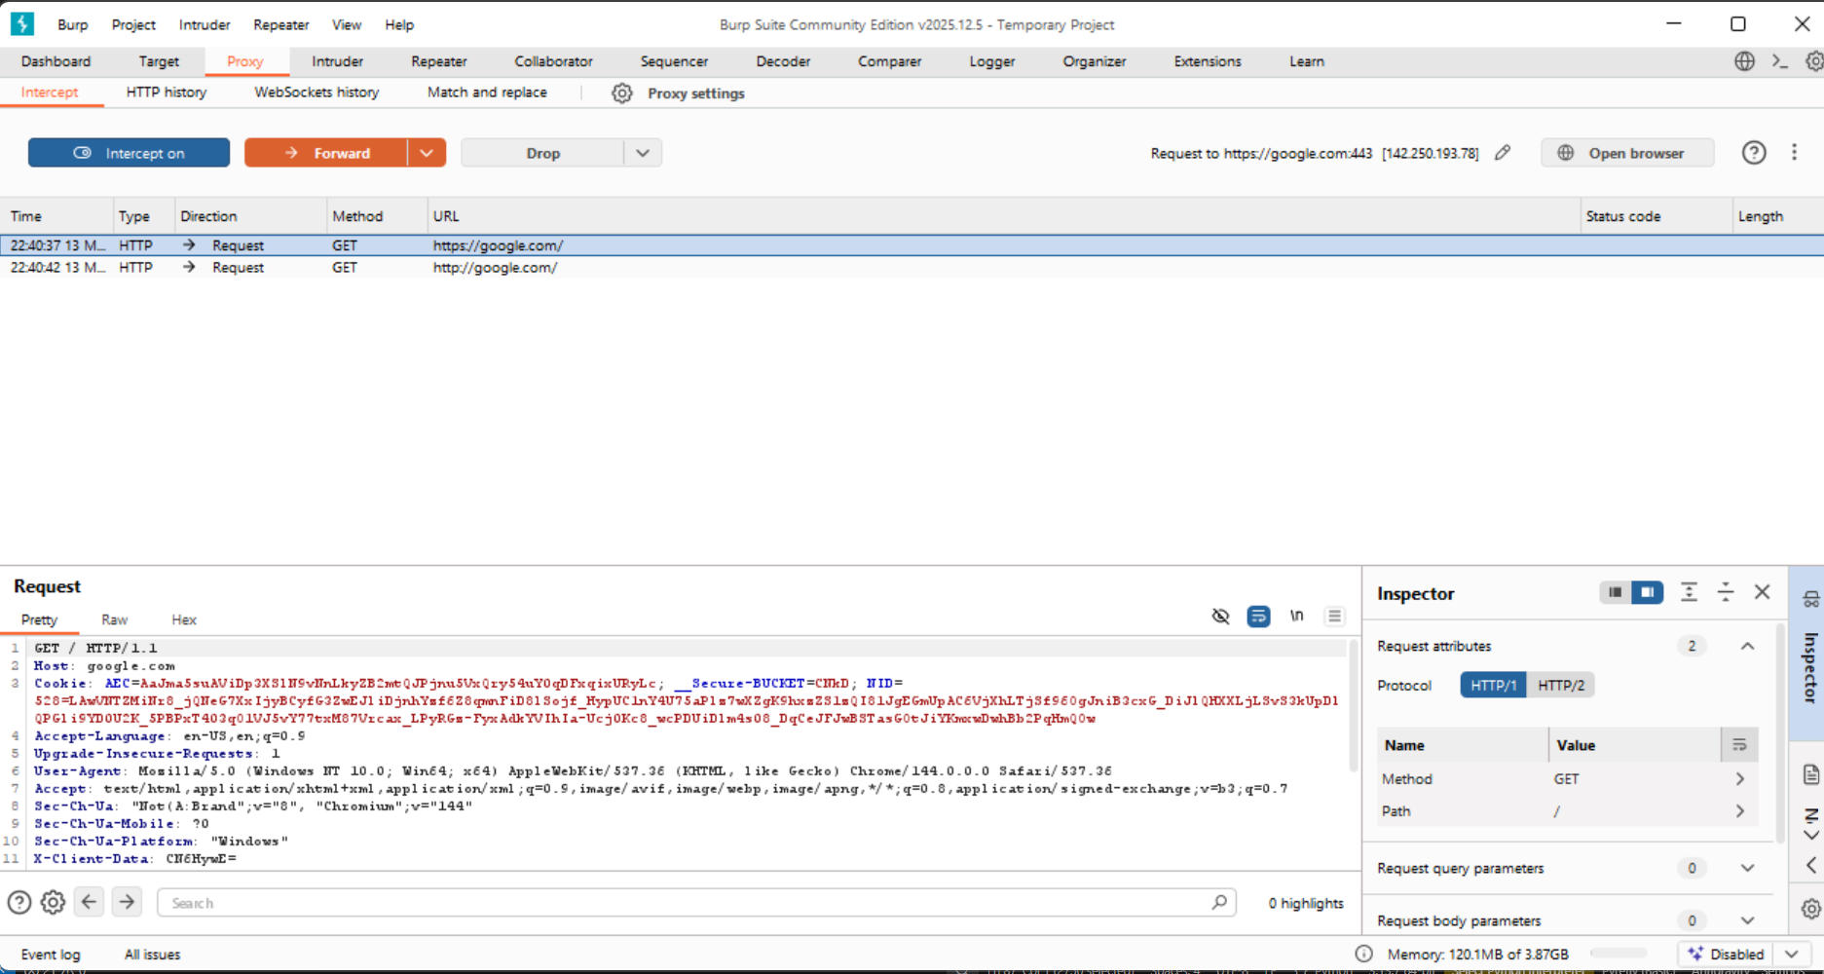
Using Burp Suite Proxy to intercept and modify traffic is a core technique for web application security testing. It allows you to see exactly what your browser sends to a server and change the data before it arrives.
Step 1: Set Up the Proxy
- Launch Burp Suite: Go to the Proxy tab and then the Intercept sub-tab.
- Check Proxy Settings: Go to Proxy > Options. By default, Burp listens on 127.0.0.1:8080.
- Configure your Browser:
  - The easiest way is to use Burp's built-in browser: Go to Proxy > Intercept and click Open Browser. This browser is pre-configured to work with Burp.
  - Alternatively, you can manually set your browser's proxy settings to 127.0.0.1 port 8080.
Step 2: Capture a Message
- Ensure Intercept is on (the button should be depressed in the Proxy > Intercept tab).
- In the browser, visit a website or submit a form (e.g., a login page).
- The browser will "hang" or appear to be loading. This is because Burp has caught the request.
- Switch to Burp Suite. You will see the raw HTTP request (including Headers, Cookies, and POST data).
Step 3: Modify the Message
Once the message is captured in the Intercept window:
- Edit the Text: You can click directly into the raw request and change values. For example:
  - Change a price=100.00 parameter to price=0.01.
  - Modify a user_role=guest cookie to user_role=admin.
  - Inject special characters like ' or <script> to test for SQLi or XSS.
- Forward the Request: Click the Forward button. The modified message is now sent to the server.
- Check the Response: If you want to see how the server responds, you can right-click the request and select "Do intercept > Response to this request" before clicking Forward.

Practical -05: Implement caesar cipher substitution operation.
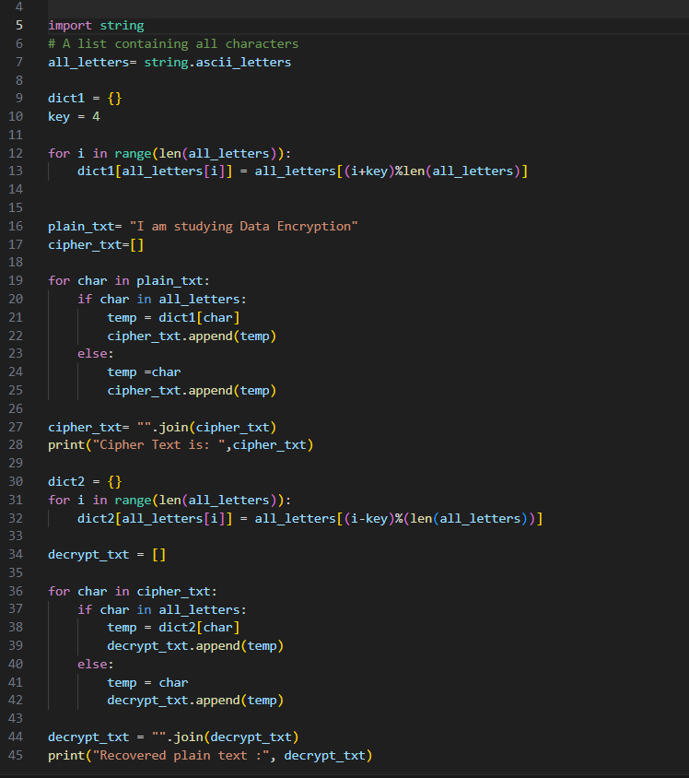
Output:
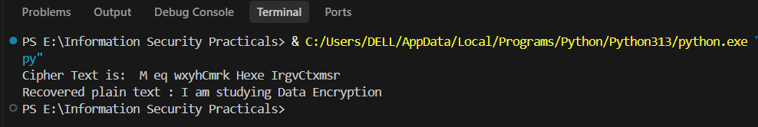

Practical-06: Implement monoalphabetic and polyalphabetic cipher substitution operation.

import string
import random

class MonoalphabeticCipher:

def __init__(self, key=None):
self.alphabet = string.ascii_lowercase
if key:
self.key = self._generate_key_from_string(key.lower())
else:
self.key = self._generate_random_key()

self.encrypt_map = str.maketrans(self.alphabet + self.alphabet.upper(),
self.key + self.key.upper())
self.decrypt_map = str.maketrans(self.key + self.key.upper(),
self.alphabet + self.alphabet.upper())

def _generate_key_from_string(self, seed_str):
# Create a unique key by taking the seed string and appending remaining letters
key = ""
for char in seed_str:
if char in self.alphabet and char not in key:
key += char
for char in self.alphabet:
if char not in key:
key += char
return key

def _generate_random_key(self):
key_list = list(self.alphabet)
random.shuffle(key_list)
return "".join(key_list)

def encrypt(self, text):
return text.translate(self.encrypt_map)

def decrypt(self, text):
return text.translate(self.decrypt_map)

class PolyalphabeticCipher:
"""
Implements the Vigenère Cipher (a common Polyalphabetic Substitution Cipher).
"""
def __init__(self, key):
self.key = key.lower()
self.alphabet = string.ascii_lowercase

def _get_key_sequence(self, text):
# Repeat the key to match the text length (ignoring non-alpha chars)
key_seq = []
key_index = 0
for char in text:
if char.lower() in self.alphabet:
key_seq.append(self.key[key_index % len(self.key)])
key_index += 1
else:
key_seq.append(None)
return key_seq

def encrypt(self, text):
key_seq = self._get_key_sequence(text)
result = []
for i, char in enumerate(text):
if char.lower() in self.alphabet:
shift = self.alphabet.index(key_seq[i])
base = ord('a') if char.islower() else ord('A')
# (P + K) mod 26
new_char = chr((ord(char) - base + shift) % 26 + base)
result.append(new_char)
else:
result.append(char)
return "".join(result)

def decrypt(self, text):
key_seq = self._get_key_sequence(text)
result = []
for i, char in enumerate(text):
if char.lower() in self.alphabet:
shift = self.alphabet.index(key_seq[i])
base = ord('a') if char.islower() else ord('A')
# (C - K + 26) mod 26
new_char = chr((ord(char) - base - shift + 26) % 26 + base)
result.append(new_char)
else:
result.append(char)
return "".join(result)

def main():

print("1. Monoalphabetic Cipher")
print("2. Polyalphabetic Cipher (Vigenère)")
choice = input("Select Cipher (1/2): ").strip()

if choice == '1':
print("\n[Monoalphabetic Cipher]")
mode = input("Generate key from word (w) or random (r)? ").lower()
if mode == 'w':
key_word = input("Enter keyword: ")
cipher = MonoalphabeticCipher(key_word)
else:
cipher = MonoalphabeticCipher()
print(f"Generated Key Alphabet: {cipher.key}")

text = input("Enter text to encrypt: ")
encrypted = cipher.encrypt(text)
decrypted = cipher.decrypt(encrypted)

print(f"\nEncrypted: {encrypted}")
print(f"Decrypted: {decrypted}")

elif choice == '2':
print("\n[Polyalphabetic Cipher (Vigenère)]")
key = input("Enter encryption key: ")
if not key.isalpha():
print("Error: Key must contain only letters.")
return

cipher = PolyalphabeticCipher(key)
text = input("Enter text to encrypt: ")

encrypted = cipher.encrypt(text)
decrypted = cipher.decrypt(encrypted)

print(f"\nEncrypted: {encrypted}")
print(f"Decrypted: {decrypted}")
else:
print("Invalid choice.")

if __name__ == "__main__":
main()

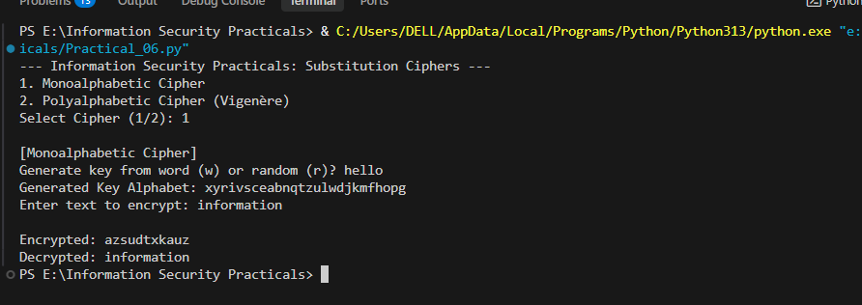

Practical -07: Implement playfair cipher substitution operation.
import numpy as np
import string

def create_matrix(key):
key = key.upper().replace("J", "I")
matrix = []

for c in key:
if c not in matrix and c.isalpha():
matrix.append(c)

for c in string.ascii_uppercase:
if c not in matrix and c != "J":
matrix.append(c)

matrix = [matrix[i:i+5] for i in range(0, 25, 5)]
return matrix

# Finding position of letter in matrix
def find_pos(matrix, letter):
for i in range(5):
for j in range(5):
if matrix[i][j] == letter:
return i, j

def prepare_text(text):
text = text.upper().replace("J", "I")
text = "".join([c for c in text if c.isalpha()])

pairs = []
i = 0

while i < len(text):
a = text[i]

if i+1 < len(text):
b = text[i+1]

if a == b:
pairs.append(a + "X")
i += 1
else:
pairs.append(a + b)
i += 2
else:
pairs.append(a + "X")
i += 1

return pairs

def encryption(text, matrix):
pairs = prepare_text(text)
result = ""

for p in pairs:
r1, c1 = find_pos(matrix, p[0])
r2, c2 = find_pos(matrix, p[1])

if r1 == r2:
result += matrix[r1][(c1+1)%5] + matrix[r2][(c2+1)%5]

elif c1 == c2:
result += matrix[(r1+1)%5][c1] + matrix[(r2+1)%5][c2]

else:
result += matrix[r1][c2] + matrix[r2][c1]

return result

def decryption(cipher, matrix):
result = ""

pairs = [cipher[i:i+2] for i in range(0, len(cipher), 2)]

for p in pairs:
r1, c1 = find_pos(matrix, p[0])
r2, c2 = find_pos(matrix, p[1])

if r1 == r2:
result += matrix[r1][(c1-1)%5] + matrix[r2][(c2-1)%5]

elif c1 == c2:
result += matrix[(r1-1)%5][c1] + matrix[(r2-1)%5][c2]

else:
result += matrix[r1][c2] + matrix[r2][c1]

return result

text = input("Enter Plain-text: ")
key = input("Enter Initial Keyword: ")

matrix = create_matrix(key)

for row in matrix:
print(row)

cipher = encryption(text, matrix)
print("\nCiphertext:", cipher)

decrypted = decryption(cipher, matrix)
print("Decrypted text:", decrypted)

Practical-08: Implement hill cipher substitution operation.

import numpy as np
def modInverse(a, m):
a = a % m
for x in range(1, m):
if (a * x) % m == 1:
return x
return None

def get_key_matrix(key_str, size):
key_str = key_str.upper().replace(" ", "")
key_matrix = []
for char in key_str:
key_matrix.append(ord(char) - ord('A'))
return np.array(key_matrix[:size*size]).reshape(size, size)

def encrypt(msg, key_matrix):
size = key_matrix.shape[0]
msg = msg.upper().replace(" ", "")

# Padding
while len(msg) % size != 0:
msg += 'X'

msg_coords = [ord(c) - ord('A') for c in msg]
msg_matrix = np.array(msg_coords).reshape(-1, size)

# C = (P * K) mod 26
# Note: Using Row vectors (msg * key) is common in some textbooks,
# while Column vectors (key * msg) is common in others.
# I'll stick to (P * K) to match your initial logic.
cipher_matrix = np.matmul(msg_matrix, key_matrix) % 26

return "".join(chr(int(c) + ord('A')) for c in cipher_matrix.flatten())

def decrypt(cipher_text, key_matrix):
size = key_matrix.shape[0]

# 1. Find determinant
det = int(np.round(np.linalg.det(key_matrix))) % 26

# 2. Find modular inverse of determinant
det_inv = modInverse(det, 26)
if det_inv is None:
return "Error: Matrix is not invertible mod 26 (GCD(det, 26) != 1)"

# 3. Find adjugate matrix (for 2x2)
if size == 2:
adj = np.array([[key_matrix[1,1], -key_matrix[0,1]],
[-key_matrix[1,0], key_matrix[0,0]]])
else:
# General adjugate using cofactor matrix (for size > 2)
# Simplified for practicals, usually 2x2 is used.
return "Decryption for size > 2 not implemented in this simple script."

# 4. Inverse matrix = det_inv * adj mod 26
inv_matrix = (det_inv * adj) % 26

cipher_coords = [ord(c) - ord('A') for c in cipher_text]
cipher_matrix = np.array(cipher_coords).reshape(-1, size)

# P = (C * K_inv) mod 26
plain_matrix = np.matmul(cipher_matrix, inv_matrix) % 26

return "".join(chr(int(round(p)) + ord('A')) for p in plain_matrix.flatten())

def main():
print("--- Hill Cipher (2x2 Matrix) ---")
print("1. Encrypt")
print("2. Decrypt")
choice = input("Select option (1/2): ")

key_input = input("Enter 4-letter key (e.g., 'HILL' or 'GYBN'): ")
if len(key_input) < 4:
print("Error: Key must be at least 4 letters for 2x2 matrix.")
return

key_matrix = get_key_matrix(key_input, 2)
print(f"Key Matrix:\n{key_matrix}")

if choice == '1':
msg = input("Enter message to encrypt: ")
result = encrypt(msg, key_matrix)
print(f"Encrypted Text: {result}")
elif choice == '2':
msg = input("Enter message to decrypt: ")
result = decrypt(msg, key_matrix)
print(f"Decrypted Text: {result}")
else:
print("Invalid choice.")

if __name__ == "__main__":
main()

Output:
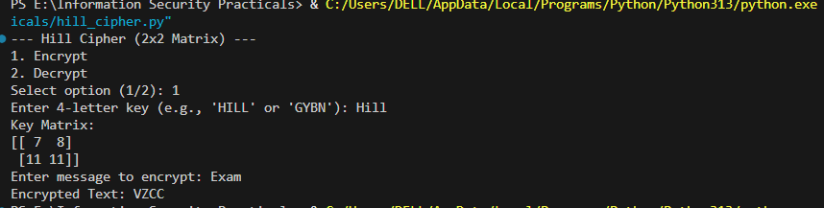

Practical-09: Implement rail fence cipher transposition operation.
def encrypt_rail_fence(text, rails):
# Create a matrix to mark the positions of characters in the zigzag pattern
fence = [['\n' for _ in range(len(text))] for _ in range(rails)]

rail = 0
direction = 1 # 1 for down, -1 for up

# Fill the fence matrix with characters in zigzag order
for i in range(len(text)):
fence[rail][i] = text[i]
rail += direction

if rail == rails - 1 or rail == 0:
direction *= -1

# Read the characters row by row to get the ciphertext
result = []
for i in range(rails):
for j in range(len(text)):
if fence[i][j] != '\n':
result.append(fence[i][j])
return "".join(result)

def decrypt_rail_fence(cipher, rails):
# Create a matrix to mark the positions of characters in the zigzag pattern
fence = [['\n' for _ in range(len(cipher))] for _ in range(rails)]

# First, mark the positions with a placeholder '*'
rail = 0
direction = 1
for i in range(len(cipher)):
fence[rail][i] = '*'
rail += direction
if rail == rails - 1 or rail == 0:
direction *= -1

# Fill the placeholders with the actual ciphertext characters row by row
index = 0
for i in range(rails):
for j in range(len(cipher)):
if fence[i][j] == '*' and index < len(cipher):
fence[i][j] = cipher[index]
index += 1

# Read the matrix in zigzag order to recover the plaintext
result = []
rail = 0
direction = 1
for i in range(len(cipher)):
result.append(fence[rail][i])
rail += direction
if rail == rails - 1 or rail == 0:
direction *= -1

return "".join(result)

def main():
print("--- Rail Fence Cipher (Transposition) ---")
print("1. Encrypt")
print("2. Decrypt")
choice = input("Select option (1/2): ")

text = input("Enter message: ")
try:
rails = int(input("Enter number of rails: "))
except ValueError:
print("Invalid number of rails.")
return

if choice == '1':
result = encrypt_rail_fence(text, rails)
print(f"Ciphertext: {result}")
elif choice == '2':
result = decrypt_rail_fence(text, rails)
print(f"Plaintext: {result}")
else:
print("Invalid choice.")

if __name__ == "__main__":
main()

Output:
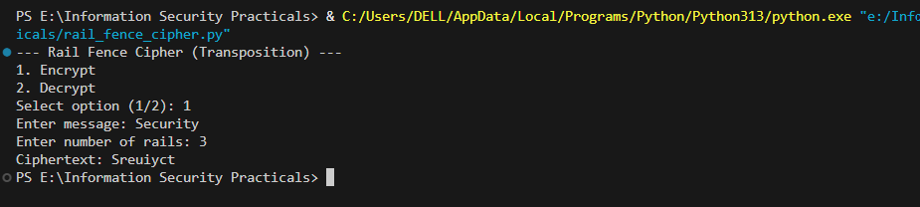

10. Implement row transposition cipher transposition operation.
def cipher_encryption():
msg = input("Enter Plain Text: ").replace(" ", "").upper()
# print(msg)
key = input("Enter keyword: ").upper()

# assigning numbers to keywords
kywrd_num_list = keyword_num_assign(key)

# printing key
for i in range(len(key)):
print(key[i], end=" ", flush=True)

print()
for i in range(len(key)):
print(str(kywrd_num_list[i]), end=" ", flush=True)

print("-------------------------")

# in case characters don't fit the entire grid perfectly.
extra_letters = len(msg) % len(key)
# print(extraLetters)
dummy_characters = len(key) - extra_letters
# print(dummyCharacters)

if extra_letters != 0:
for i in range(dummy_characters):
msg += "."

# print(msg)

num_of_rows = int(len(msg) / len(key))

# Converting message into a grid
arr = [[0] * len(key) for i in range(num_of_rows)]
z = 0
for i in range(num_of_rows):
for j in range(len(key)):
arr[i][j] = msg[z]
z += 1
# for
# for

for i in range(num_of_rows):
for j in range(len(key)):
print(arr[i][j], end=" ", flush=True)
print()
# for

# getting locations of numbers
num_loc = get_number_location(key, kywrd_num_list)

print(num_loc)

cipher_text = ""

for k in range(len(key)): # Loop through each column in the sorted order
d = int(num_loc[k]) # Get the actual index of the column to read
for j in range(num_of_rows): # Loop down through every row of that column
cipher_text += arr[j][d]

print("Cipher Text: {}".format(cipher_text))

def get_number_location(key, kywrd_num_list):
num_loc = ""
for i in range(len(key) + 1):
for j in range(len(key)):
if kywrd_num_list[j] == i:
num_loc += str(j)

return num_loc

def keyword_num_assign(key):
alpha = "ABCDEFGHIJKLMNOPQRSTUVWXYZ"
kywrd_num_list = list(range(len(key)))
# print(kywrdNumList)
init = 0
for i in range(len(alpha)):
for j in range(len(key)):
if alpha[i] == key[j]:
init += 1
kywrd_num_list[j] = init

return kywrd_num_list

def cipher_decryption():
msg = input("Enter Cipher Text: ").replace(" ", "").upper()
# print(msg)
key = input("Enter keyword: ").upper()

# assigning numbers to keywords
kywrd_num_list = keyword_num_assign(key)

num_of_rows = int(len(msg) / len(key))

# getting locations of numbers
num_loc = get_number_location(key, kywrd_num_list)

# Converting message into a grid
arr = [[0] * len(key) for i in range(num_of_rows)]

# decipher
plain_text = ""
k = 0
itr = 0

# print(arr[6][4])
# itr = len(msg)

for i in range(len(msg)):
d = 0
if k == len(key):
k = 0
else:
d: int = int(num_loc[k])
for j in range(num_of_rows):
arr[j][d] = msg[itr]
# print("j: {} d: {} m: {} l: {} ". format(j, d, msg[l], l))
itr += 1
if itr == len(msg):
break
k += 1
print()

for i in range(num_of_rows):
for j in range(len(key)):
plain_text += str(arr[i][j])

print("Plain Text: " + plain_text)

def main():
choice = int(input("1. Encryption\n2. Decryption\nChoose(1,2): "))
if choice == 1:
print("Encryption")
cipher_encryption()
elif choice == 2:
print("Decryption")
cipher_decryption()
else:
print("Invalid Choice")

if __name__ == "__main__":
main()

Output:
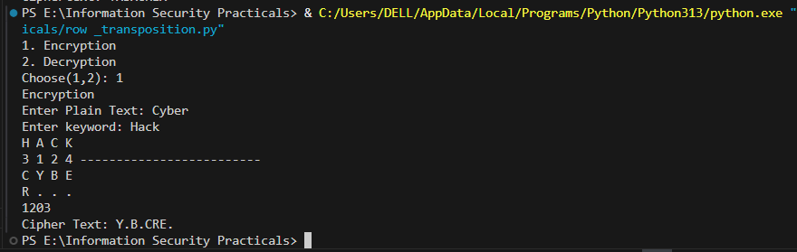

Practical-11: Implement product cipher transposition operation.
def caesar_cipher(text, shift, encrypt=True):
result = ""
if not encrypt:
shift = -shift

for char in text:
if char.isalpha():
base = ord('A') if char.isupper() else ord('a')
result += chr((ord(char) - base + shift) % 26 + base)
else:
result += char
return result

def rail_fence_encrypt(text, rails):
fence = [['\n' for _ in range(len(text))] for _ in range(rails)]
rail, direction = 0, 1
for i in range(len(text)):
fence[rail][i] = text[i]
rail += direction
if rail == rails - 1 or rail == 0:
direction *= -1
return "".join(fence[i][j] for i in range(rails) for j in range(len(text)) if fence[i][j] != '\n')

def rail_fence_decrypt(cipher, rails):
fence = [['\n' for _ in range(len(cipher))] for _ in range(rails)]
rail, direction = 0, 1
for i in range(len(cipher)):
fence[rail][i] = '*'
rail += direction
if rail == rails - 1 or rail == 0:
direction *= -1

index = 0
for i in range(rails):
for j in range(len(cipher)):
if fence[i][j] == '*' and index < len(cipher):
fence[i][j] = cipher[index]
index += 1

result, rail, direction = [], 0, 1
for i in range(len(cipher)):
result.append(fence[rail][i])
rail += direction
if rail == rails - 1 or rail == 0:
direction *= -1
return "".join(result)

def product_encrypt(text, shift, rails):
# Step 1: Substitution
substituted = caesar_cipher(text, shift)
# Step 2: Transposition
ciphered = rail_fence_encrypt(substituted, rails)
return ciphered

def product_decrypt(cipher, shift, rails):
# Step 1: Reverse Transposition
transposed_back = rail_fence_decrypt(cipher, rails)
# Step 2: Reverse Substitution
original = caesar_cipher(transposed_back, shift, encrypt=False)
return original

def main():
print("--- Product Cipher (Substitution + Transposition) ---")
print("1. Encrypt")
print("2. Decrypt")
choice = input("Select option (1/2): ")

text = input("Enter message: ")
try:
shift = int(input("Enter substitution shift (e.g., 3): "))
rails = int(input("Enter transposition rails (e.g., 2): "))
except ValueError:
print("Invalid input for shift or rails.")
return

if choice == '1':
result = product_encrypt(text, shift, rails)
print(f"Final Ciphertext: {result}")
elif choice == '2':
result = product_decrypt(text, shift, rails)
print(f"Decrypted Message: {result}")
else:
print("Invalid choice.")

if __name__ == "__main__":
main()

Output:
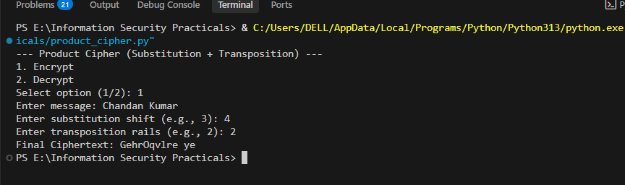

THANK YOU!

